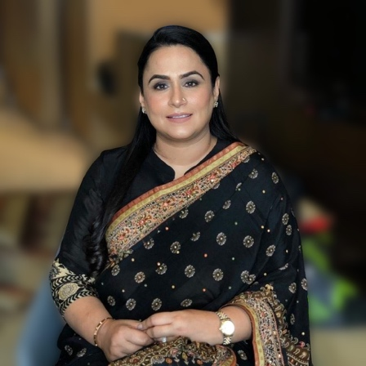
Dr. Simarpreet Virk Sandhu ( M.D.S, M.A.M.S)
Dr. Simarpreet Virk Sandhu is a dynamic personality and has taken Oral Pathology in Northern India to new heights. She is currently the Professor and Head of the Department of Oral & Maxillofacial Pathology at Genesis Institute of Dental Sciences & Research, Ferozepur (Punjab). Under her leadership the postgraduate programme started in the department in 2010 and is the only centre in Punjab offering the postgraduate programme in Oral & Maxillofacial Pathology.
She has a research experience of over 20 years and has published more than 80 peer reviewed papers as author/co-author in national and international journals of repute and has contributed to 6 textbooks. Has chaired and judged scientific sessions; presented papers in various National and International Conferences. A powerful orator the doctor is a sought after speaker in various speciality national and international conferences. She has been an Executive Member & Vice President of Indian Association of Maxillofacial Pathologists. Presently the Secretary-general of Asian Society
Oral Maxillofacial Pathologists (ASOMP). She is a Nominated member of NAMS (National Academy of Medical Sciences) and was conferred the prestigious Dr. R.M. Mathur 2012 by the IAOMP & Women of Purpose by FLO in 2019. She has served in various capacities in the editorial board and is a peer reviewer in several prestigious scientific journals. She has successfully completed various research projects and her research interests include Oral Cancer: epidemiology, ethnic variation, aetiology and early detection.
She has been actively involved in organising various conferences and symposia and was the Organising Chairperson of the XXVII National IAOMP Conference which was held in Amritsar for the first time since the inception of the IAOMP in 1991. She is actively crusading for the early detection and prevention of oral cancer and is working closely with several NGOs and campaigns against smokeless tobacco. She is the Treasurer of FICCI FLO Amritsar Chapter of Country's most prestigious and renowned Women organisation running over 33 years.

-----------------------------------------------------

